

**National University of Computer & Emerging Sciences (FAST-NU)**

**CRYPTOCURRENCY PRICE PREDICTION**

**Course Teacher**

Sir Atif Tahir

**Project Team**

Huzaifa Ashraf -k163715

**SUBMISSION DATE**

May 31st,2021

DEPARTMENT OF COMPUTER SCIENCE

NATIONAL UNIVERSITY OF COMPUTER & EMERGING SCIENCES KARACHI CAMPUS

**RESEARCH GOAL:**

The riskiest asset is one of the most popular currently during a chaotic year in the markets. Bitcoin is back in 2020 after a historic rise and fall three years ago. A wave of investor enthusiasm is driving it to all-time highs, as it was last time, and bitcoin enthusiasts believe this is just the beginning. They see bitcoin as a financial system revolution; this has been the message for over 11 years, and people are finally starting to pay attention. However, many bitcoin specialists warn that the asset is excessively volatile for normal investors and that it is a purely speculative play that will not scale.The goal of our research is to find out whether we can predict the prices of crypto currencies and then use that data to make investment decisions in cryptocurrency.This research can help many people who are still unsure or are thinking about investing in the crypto market.

**What is cryptocurrency?**

Cryptocurrencies, unlike traditional investments, are not linked to tangible assets or the US dollar. The sole goal of cryptocurrency is to allow two people in any location to directly exchange value. That is to say, there is no single central authority running this network, no government, and no central bank with the power to shut it down or arbitrarily raise or drop its value.

Cryptocurrency is merely software at its foundation, running on a network of interconnected yet separate computers. They are used to keep track of transactions between people all around the world. Rather than being managed by a single master computer or a single entity, the information is duplicated on every computer in the network. This is a cryptocurrency blockchain that anybody can access, which prevents counterfeiting, double spending, and makes bitcoin a secure currency.

Every time someone makes a transaction, the ledger is updated with a unique encrypted signature for verification. That signature, once confirmed and finalised, cannot be changed or altered, which means you can't counterfeit a cryptocurrency. This is what keeps the network honest. Crypto proponents claim that the network is impenetrable, however this isn't always the case.The issue is that to hack it you would have to take over the network, you would need your own network of computers running 24/7 and to do that would cost billions of dollars. You can do, but it isn't really feasible.

**Retrieving Data:**

So the first thing that we are going to want to do is collect data. We will use the data from data world which can be downloaded from here (<https://data.world/og5136/cryptocurrency-price-data-2013-2018>)

We want to make sure that we are using enough historical data to make the model more accurate. We are using historical data for cryptocurrencies from Dec 2013 to Dec 2017.

**Data Prepared:**

We are using various techniques to prepare our data which include:

* Extraction crypto currencies we need which in our case are (Bitcoin,Ehthereum)
* Extracting Date and Close price of currencies as we are predicting the Close Price.
* Checking if there are any null values
* Checking if the data is in right format for example in float ,datetime or int.

**Data Exploration:**

Since we are predicting the close prices of both bitcoin and ethereum we need to observe the trend in both currencies.

**Bitcoin:**

This is what are final table looks like for bitcoin after data preparation.

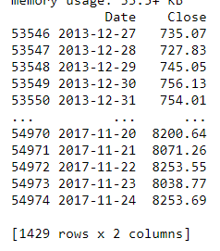

After Exploring the data we can see the trend in our bitcoin data:

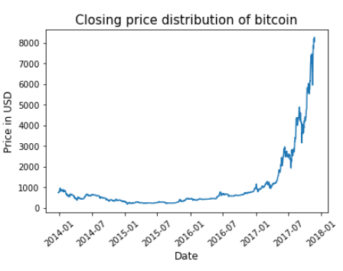

As we can see the close prices of bitcoin are going higher year by year.

**Ethereum:**

This is what are final table looks like for ethereum data preparation:

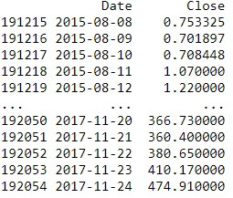

After Exploring the data we can see the trend in our Ethereum data:

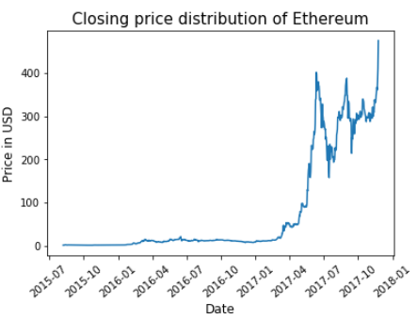

As we can see ethereum has more fluctuations in close prices than bitcoin.

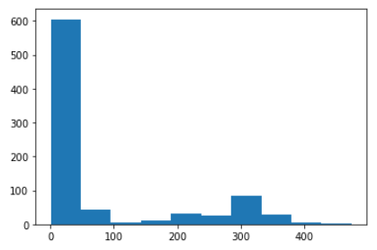

As we can see the ehtereum prices remained between 0 to 100 dollars for most of the time.

**DATA MODELLING:**

**Testing the stationary:**

We will first check whether our data graphs are stationary nor not.

For that we will use The Augmented Dicky Fuller test.

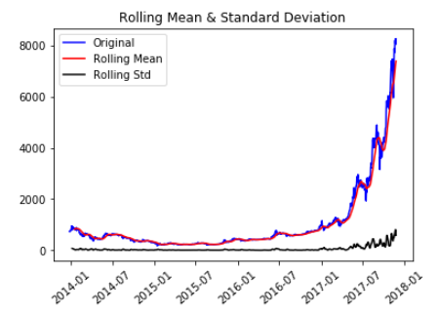

In our case the series was non stationary so we have to make it stationary.

**Log Transforming the series:**

Log transformation helps us to unskew highly skewed data.

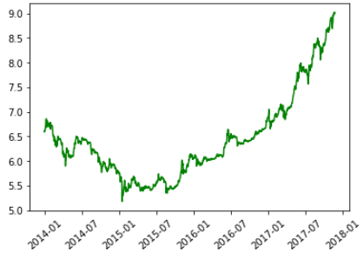

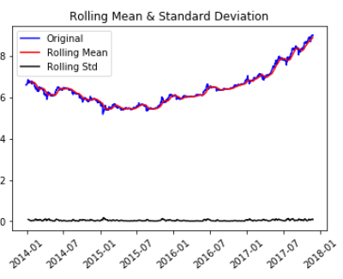

The series is still unstationary so we apply other teschniques to make it stationary.

**Remove trend and seasonality with differencing:**

With this technique our mean is stabilized and chances of stationary series increases:

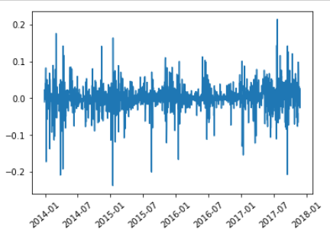

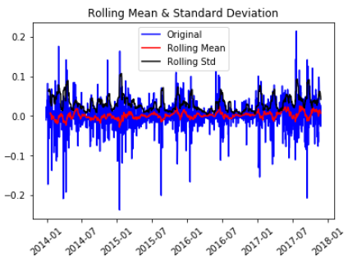

Our series has become stationary so we can move to applying time series prediction models.

**Time Prediction Model:**

We are using three model

* Auto Regressive Model
* Moving Average Model
* ARIMA

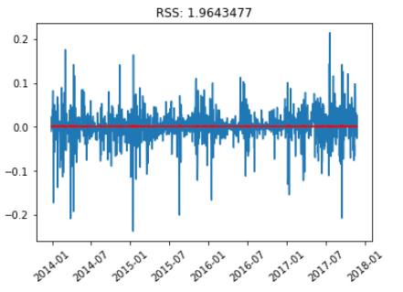

Results of AR MODEL

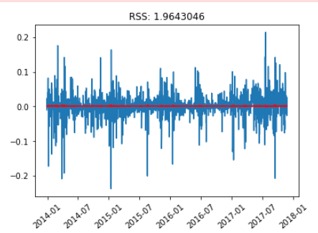

Results of MV MODEL

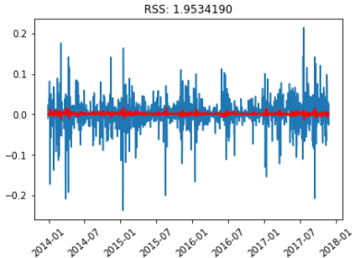

Results of ARIMA

The value of RSS is the minimum for ARIMA so this is the model for us lets apply it.

For every value in the test test we apply an ARIMA model and then the error is calculated and then after iterating over all values in the test set the mean error between predicted and expected value is calculated.

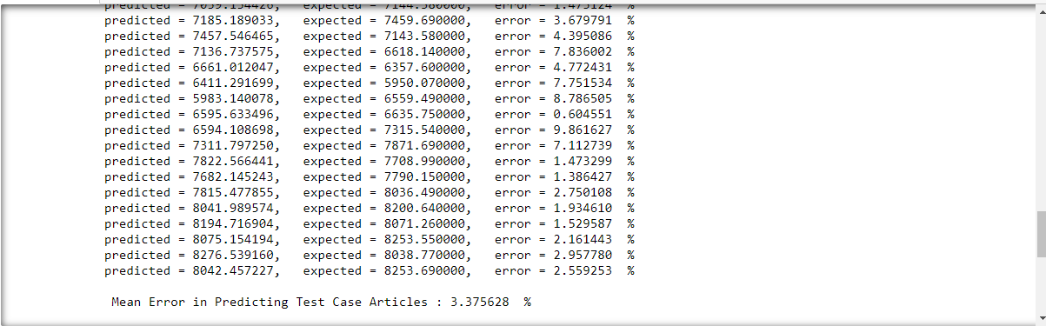

**PRESENTATION:**

After applying model are results are here and we have done this on both bitcoin and ethereum but we have shown results above for bitcoin because the report is becoming lengthy.

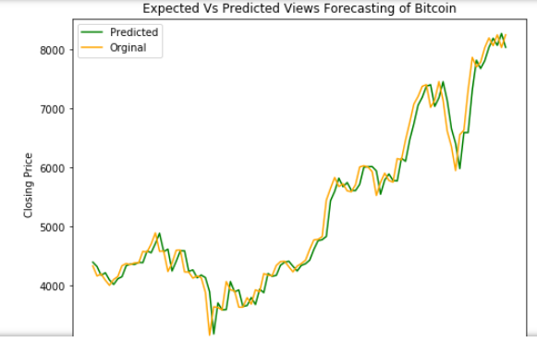

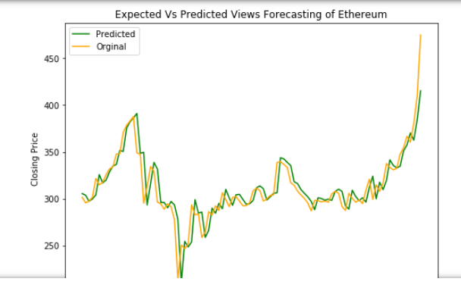

The results of our prediction model are good if not accurate.

**Conclusion:**

We have tried our best to deal with this research problem and have learnt a lot in this process.This project was amazing and fun to do.